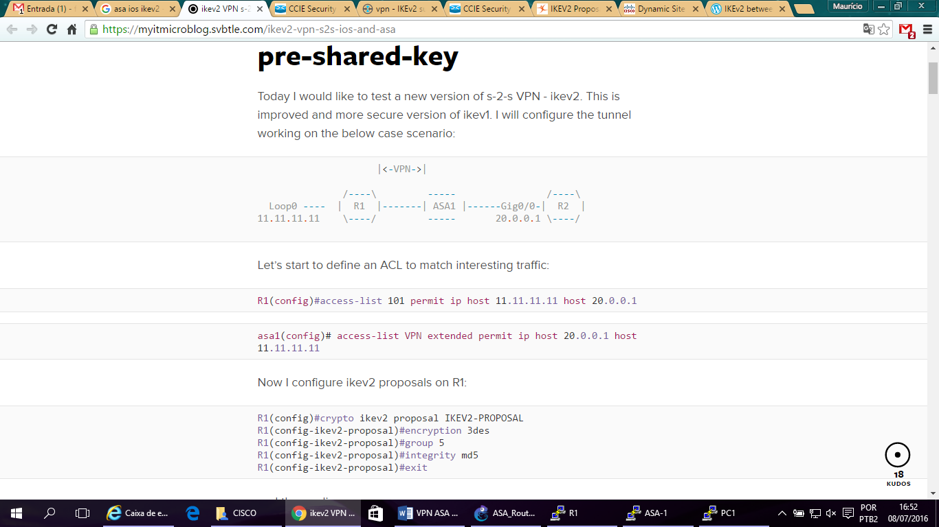

[**https://myitmicroblog.svbtle.com/ikev2-vpn-s2s-ios-and-asa**](https://myitmicroblog.svbtle.com/ikev2-vpn-s2s-ios-and-asa)

**Configuração**

**------------------------------------------------------------------------------------**

**- ASA -**

**------------------------------------------------------------------------------------**

hostname asa1

!

interface gig0

nameif outside

security-level 0

ip address 10.0.0.2 255.255.255.0

no sh

exit

!

interface gig 1

nameif inside

security-level 100

ip address 20.0.0.2 255.255.255.0

no sh

exit

!

access-list VPN extended permit ip host 20.0.0.1 host 11.11.11.11

!

route outside 11.11.11.11 255.255.255.255 10.0.0.1 1

!

crypto ipsec ikev2 ipsec-proposal IPSEC-PROPOSAL

protocol esp integrity md5

protocol esp encryption 3des

exit

!

crypto map MAPA 10 match address VPN

crypto map MAPA 10 set peer 10.0.0.1

crypto map MAPA 10 set ikev2 ipsec-proposal IPSEC-PROPOSAL

crypto map MAPA interface outside

!

crypto ikev2 policy 10

encryption 3des

integrity md5

group 5

prf md5

exit

!

crypto ikev2 enable outside

!

tunnel-group 10.0.0.1 type ipsec-l2l

tunnel-group 10.0.0.1 ipsec-attributes

ikev2 remote-authentication pre-shared-key cisco123

ikev2 local-authentication pre-shared-key cisco123

exit

!

**------------------------------------------------------------------------------------**

**- R1: -**

**------------------------------------------------------------------------------------**

hostname R1

!

crypto ikev2 proposal IKEV2-PROPOSAL

encryption 3des

integrity md5

group 5

exit

!

crypto ikev2 policy IKEV2-POLICY

proposal IKEV2-PROPOSAL

exit

!

crypto ikev2 keyring KEYRING

peer 10.0.0.2

address 10.0.0.2

pre-shared-key local cisco123

pre-shared-key remote cisco123

exit

exit

!

!

!

crypto ikev2 profile IKEV2-PROFILE

match identity remote address 10.0.0.2 255.255.255.255

authentication remote pre-share

authentication local pre-share

keyring local KEYRING

exit

!

!

crypto ipsec transform-set TS esp-3des esp-md5-hmac

mode tunnel

exit

!

!

!

crypto map MAPA 10 ipsec-isakmp

set peer 10.0.0.2

set transform-set TS

set ikev2-profile IKEV2-PROFILE

match address 101

exit

!

!

interface fas 1/0

ip address 11.11.11.11 255.255.255.0

no sh

exit

!

interface fas 0/0

ip address 10.0.0.1 255.255.255.0

crypto map MAPA

no sh

exit

!

ip route 0.0.0.0 0.0.0.0 10.0.0.2

!

access-list 101 permit ip host 11.11.11.11 host 20.0.0.1

!

--